

**(Online Voting)**

**Manual for Administrators and Voters**

**ADMINISTRATOR (ADMIN PAGE)**

**Log-In Page**



In order to access the page, the administrator has to log-in first by typing his or her username and password.

**Example:**

**Username:** admin

**Password:** 12567

After typing the username and password, click the submit button. A message will appear if the log-in process is successful or fail.

**Content of Admin**



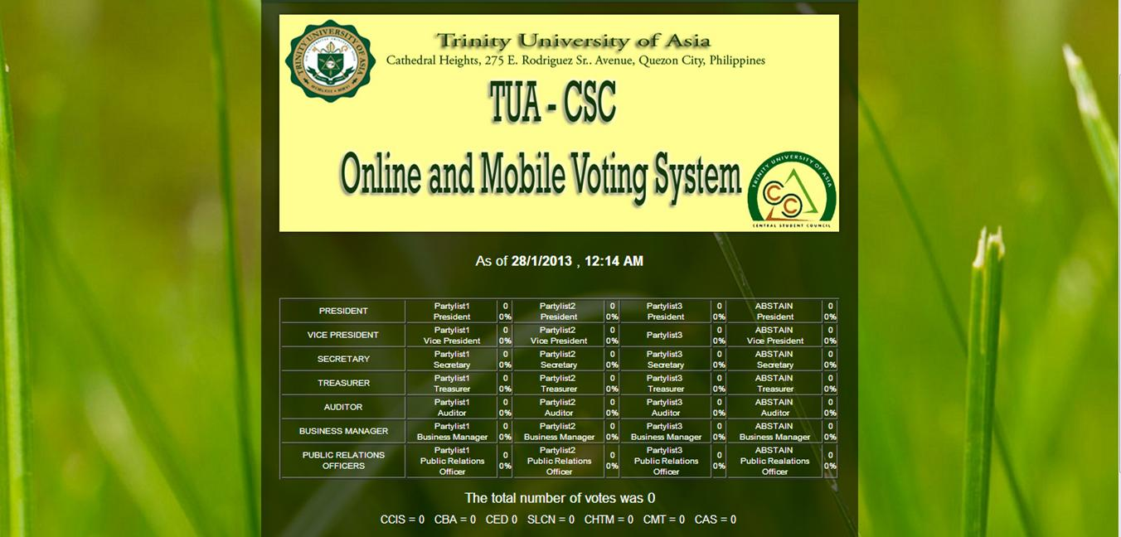

This is the place where the tallying of votes happens. Only the admin can view who are the leading candidates and from what partylist they belong. It also includes the total number of votes per College.

**Manage School Year**





Set the school year when will the student council election happen. **Example:** 2015-2016. After setting it, click the submit button to update the page. A message is display indicating the school year has been change or it has an error.

**Manage Candidates**

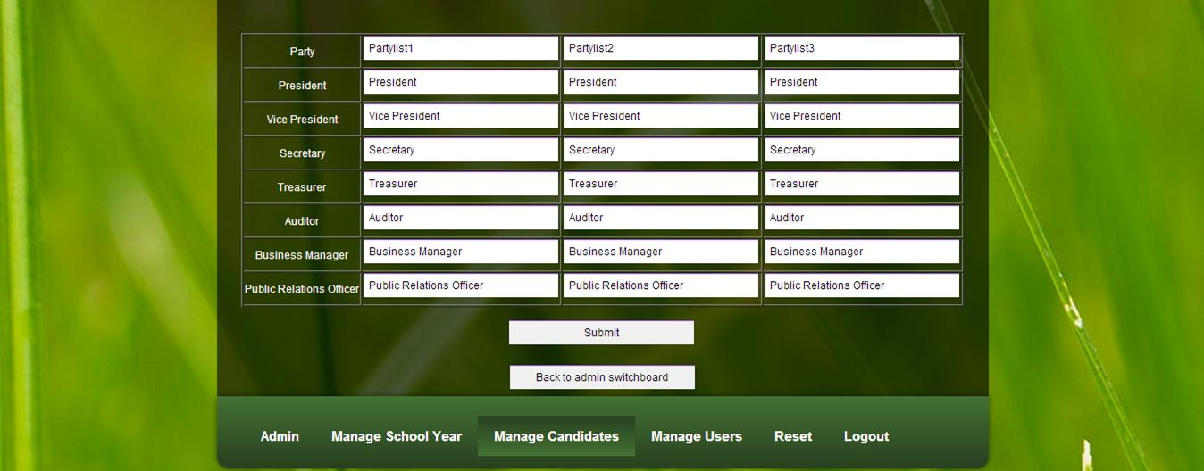



In this page, type the names of the candidates running for the student council election. Including their positions and party lists where they belong. The Central Student Council have 7 officers which are the President, Vice President, Secretary, Treasurer, Auditor, Business Manager and Public Relations Officer (PRO). After the filling-up process, click the submit button to update the page. A message is display indicating that it is added, changed or if there is a problem.

**Manage Users**

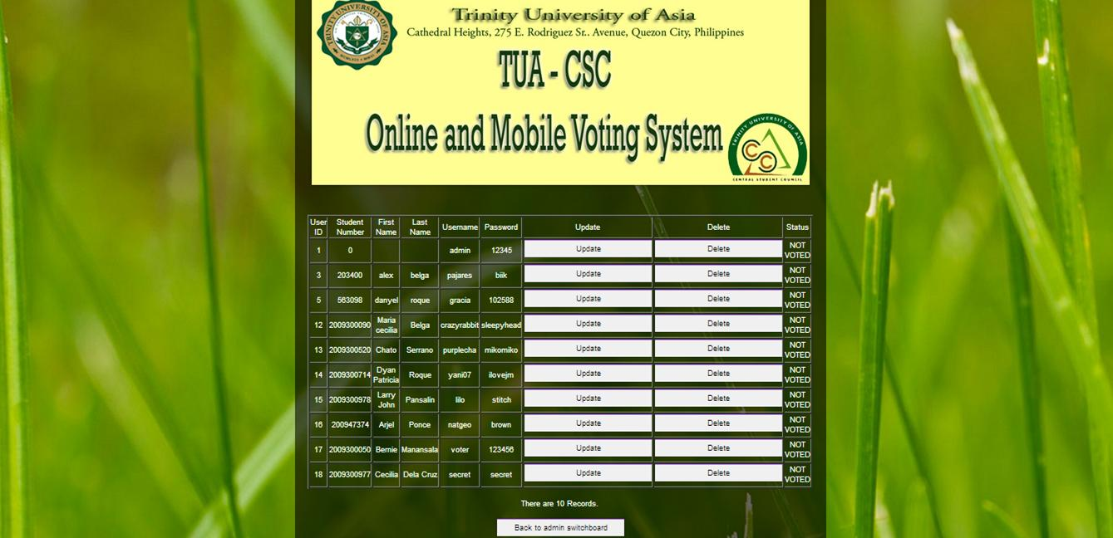

Manage users page is about the student voters. Here you can view their information such as their student number, first name, last name, username and password that they use in order to cast a vote. It has also student status that serves for knowing if the student voter already cast a vote or not. If the admin wants to correct a misspelled name just click the “Update Button” and a dialogue box appear.

**Example:**

If the admin updates the user’s password, he/she just have to erase the old one and type the new one after this, click the “update”.



After clicking “update” the user’s password is change.

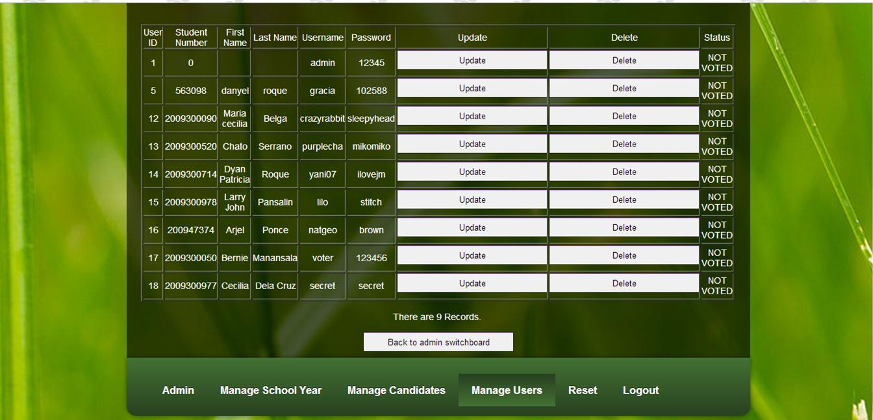

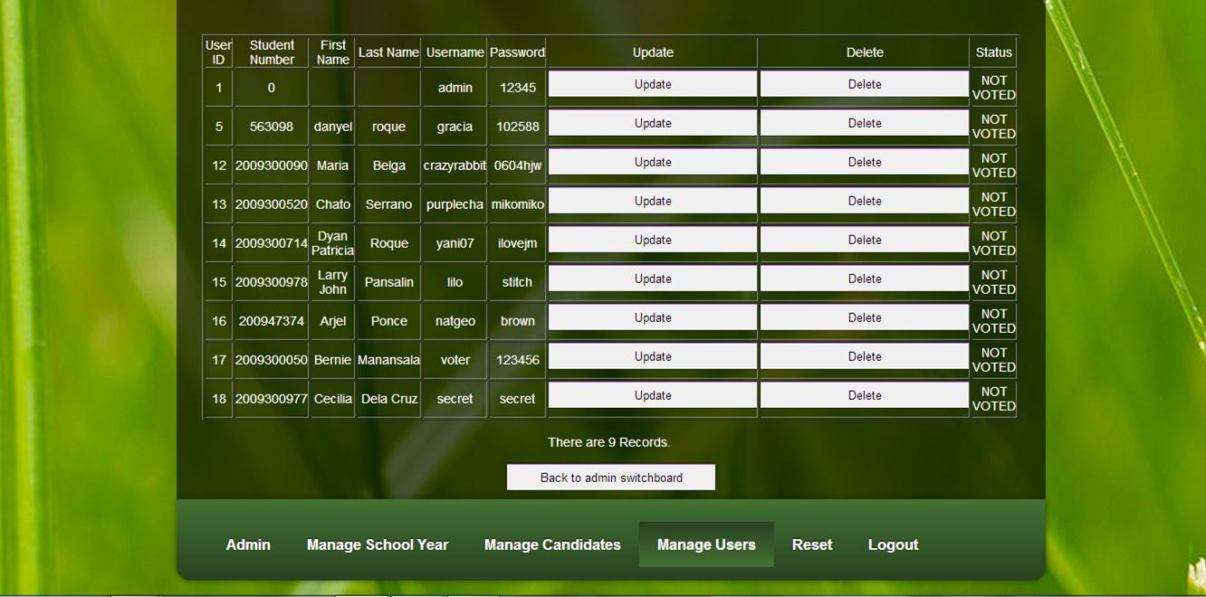

**Manage Users (continuation)**

It has also the “Delete Button”, by just clicking it all of the information about a particular voter will be automatically deleted from the system. A message will appear saying how many records are remaining.

**Example:**



Before, it has 10 records.



But after deleting one student record, it only has 9 records.



**Reset Button**

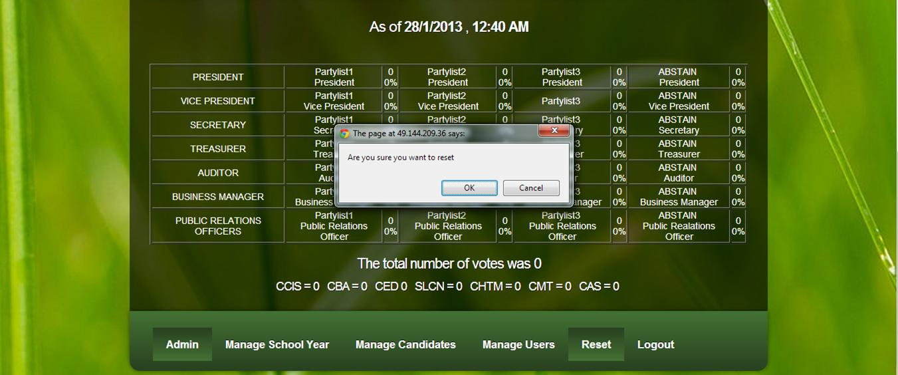

By clicking the **“**Reset button” a dialogue box will appear asking for permission if he/she really wants to set back to zero the number of votes. If the admin choose to click “Ok” automatically all the number of votes will be set to zero, if the admin choose to click “Cancel” nothing will happen.

**VOTER PAGE**

**Log-In Page**



In order to access the page, the voter/user has to log-in first by typing his or her “student number” as the username and his or her “surname” as the password.

**Example:**

**Username:** 2009300978

**Password:** pansalin

After typing the username and password, click the submit button. A message will appear if the log-in process is successful or fail.

**Voting Page**

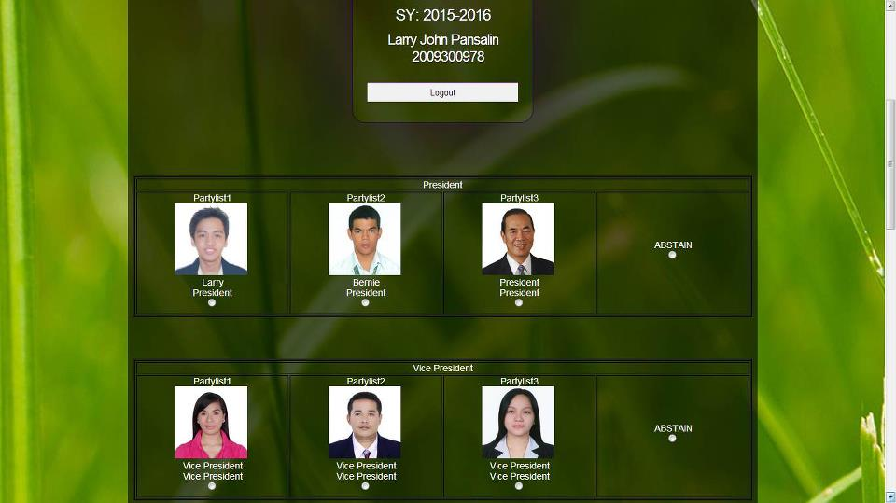

After the voter had log-in with their student number and surname, an online ballot will appear. In this page the voter can now vote his or her favoured candidates by clicking the radio button below the photos.

If the voter decided not to vote for a certain candidate in a certain position the voter may click the abstain button. The voters are not force to vote in all positions according to OSA.

After the voter finish voting, he or she may click the “submit vote button” below the page.

Then the voter may now log-out after voting.

Remember only one vote is given to every voter, voting twice will not be counted.



**(Mobile Voting User’s Manual)**

Keywords:

p1/p2/p3 – president

vp1/vp2/vp3 – vice president

sec1/sec2/sec3 – secretary

tre1/tre2/tre3 – treasurer

aud1/aud2/aud3 – auditor

bus1/bus2/bus3 – business manager

pro1/pro2/pro3 – public relation offier

Format:

VOTE <space>student number<space>candidates keywords

Example:

VOTE<space>2009300050<space>p1_vp2_sec3_tre2_aud1_bus1_pro3